Team 8 VLSI Report

12 –

1. S
   1. 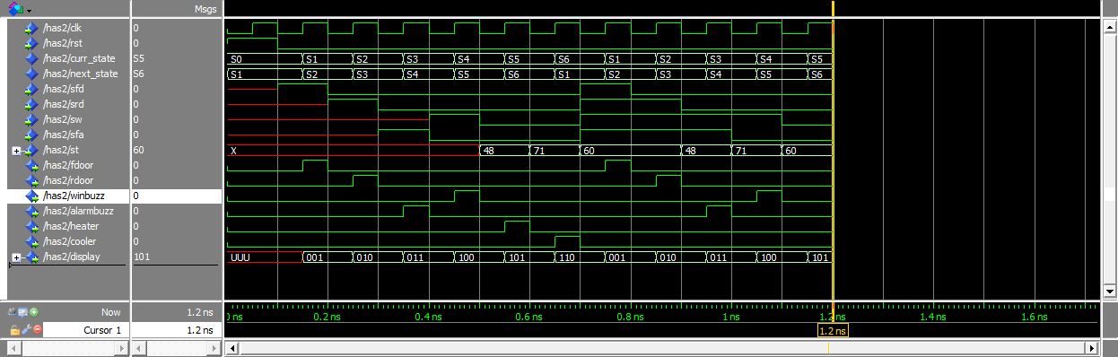Pre-Synthesis Simulation Screenshot
   2. Graphical user interface, diagram

      Description automatically generated Design Schematic After Synthesis Screenshot
   3. 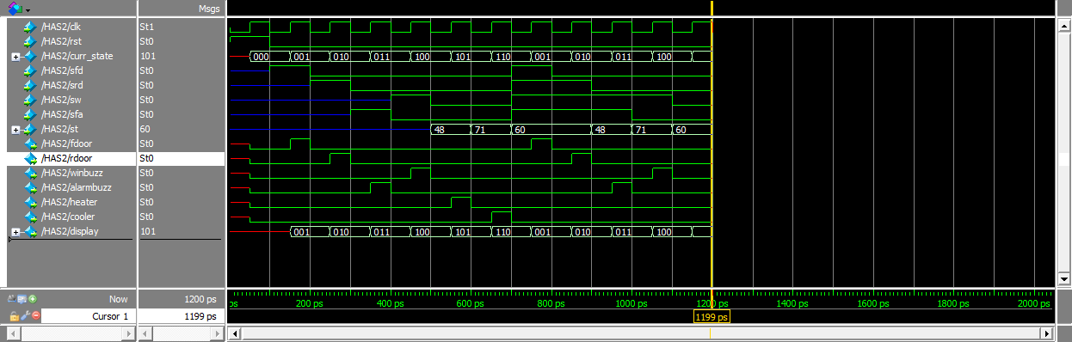Post-Synthesis Simulation Screenshot
   4. Chip Schematic ScreenshoA screenshot of a computer

      Description automatically generatedt
   5. Table

      Description automatically generatedDesign
   6. Path

* 1. Table

     Description automatically generatedPower

1. Justification
2. Score

0.5 * 68 + 0.3 * (1500 – 670.9) + 0.2 * (91.643) = **301.0586**